**TeesForYou.com (E-Commerce)**

=> Site where you can buy printed Tshirts, sweatshirts, TankTops, Hoodies online

**TYPES OF USERS:**

1.Customer

2.Seller/Admin

**WIREFRAME:**

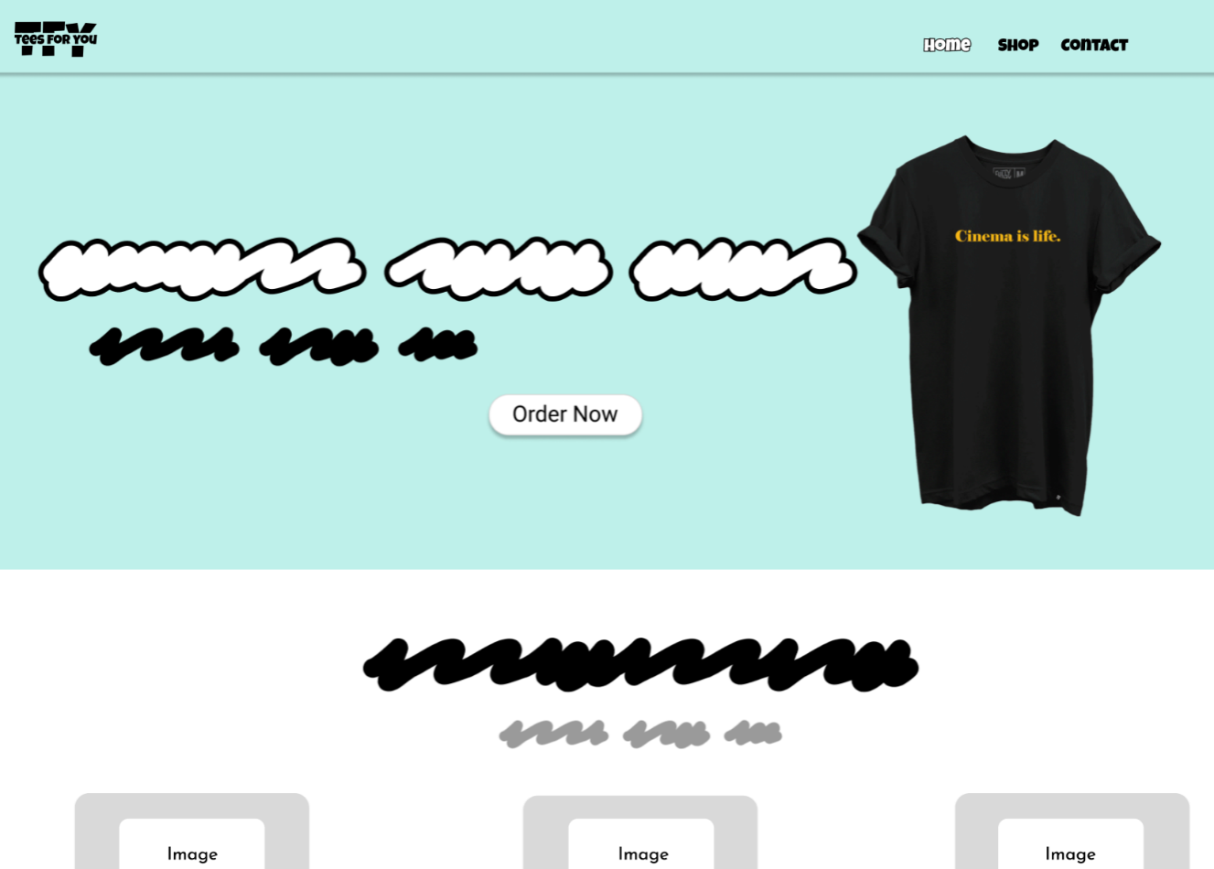 # Home Page:

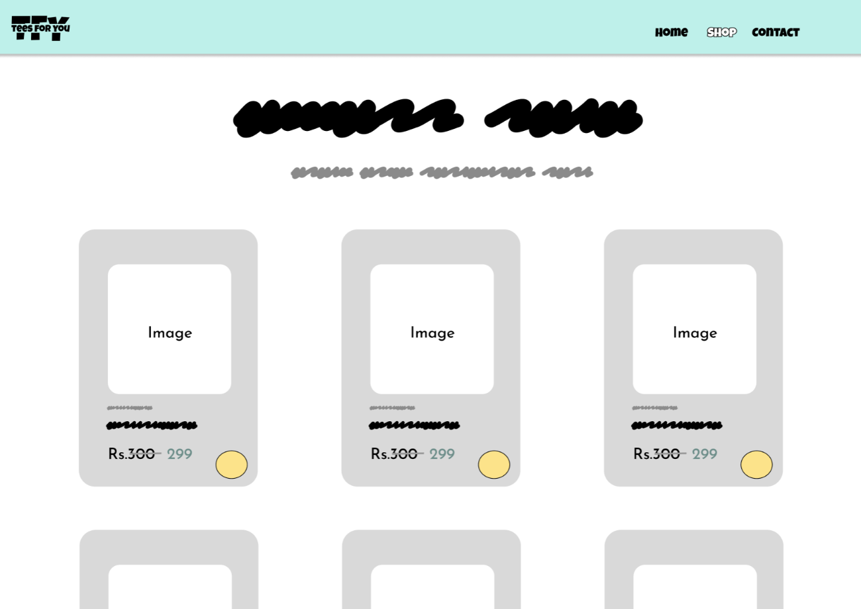# Shop Page:

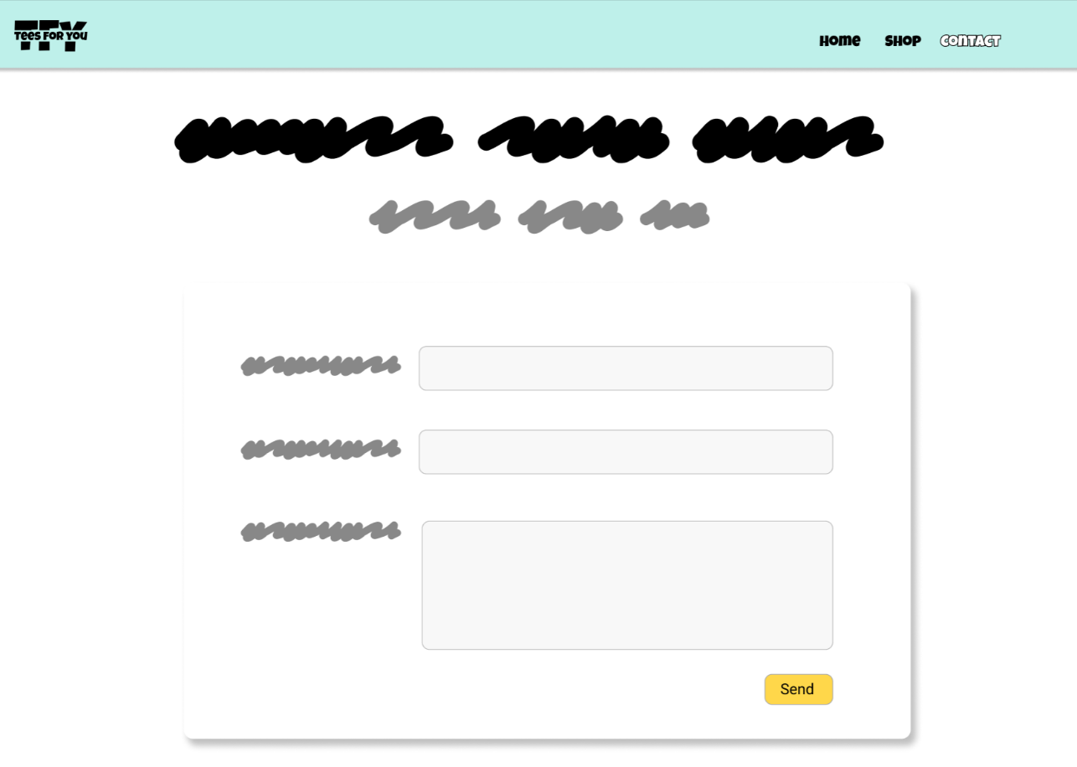# Contact Page:

# Login Page:

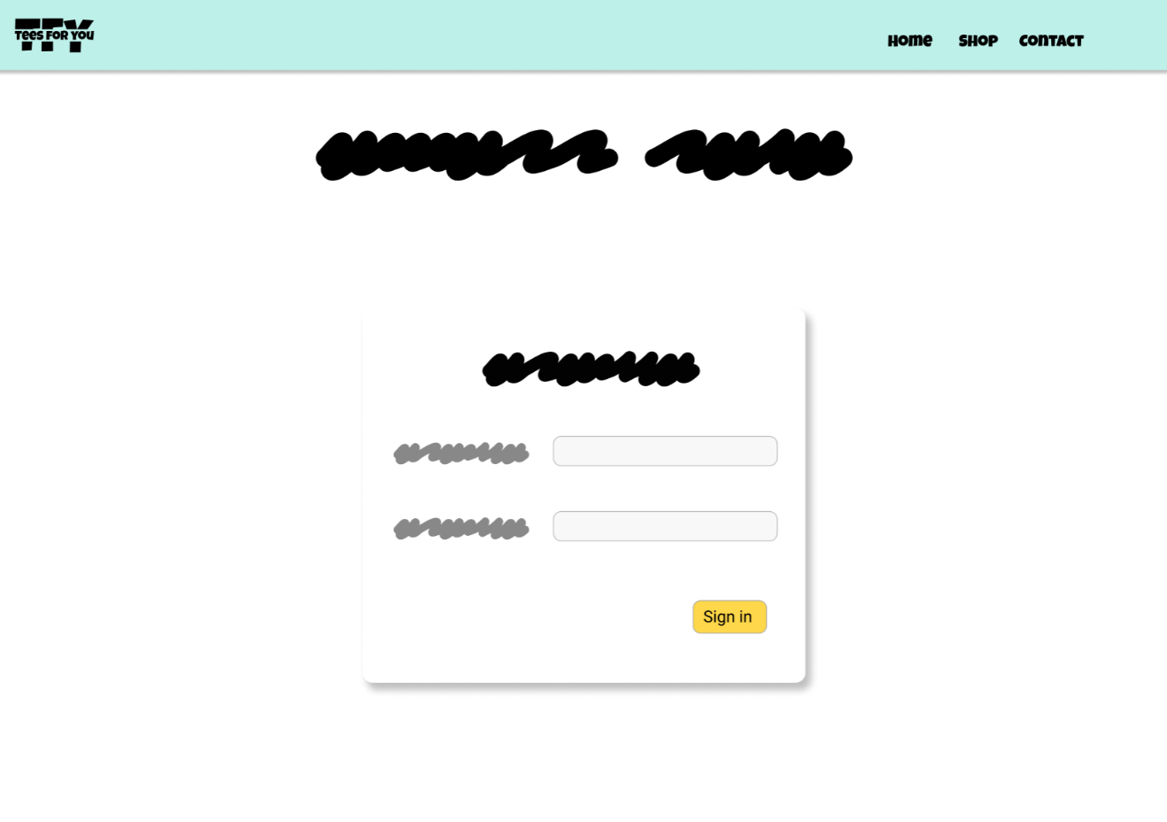

**FUNTIONALITIES**

**1.Customer:**

# Signin / Signup page (Using mail/Phone No.)

# selecting the type of product (Tshirt, sweatshirts, TankTops, Hoodies)

# Order Details(Size, color, No. of units)

# Checkout (Address, Payment mode)

**2.Admin:**

# Admin Signin

# DashBoard for Orders placed

# Adding / Editing Products list and its details

**INPUTS & ACTIONS:**

*Inputs - These elements collect data from the user*

*Action - These elements have specific functionality which requires Javascript*

**1.Customer:**

**# SignUp**

*Input :* Name, PhoneNo./Email, password

*Action:* SignUp_button, Show/hide_Password_button

**# SignIn**

*Input :* PhoneNo./Email, password

*Action:* SignIn_button, Account_Authentication, Show/hide_Password_button

**# Selecting product**

*Input :* Product_size, product_quantity

*Action:* Product_Cards (takes to order details page)

**# Order Details**

*Input :* Size, color, No. of units, Address, Payment_mode

*Action:* AddToCart_button, BuyNow_button

**# CheckOut**

*Input :* Address, Payment_mode

*Action:* PlaceOrder_button, Ok_button, Save_button, Cancel_button

**2.ADMIN:**

**# SignIn**

*Input :* Email, password

*Action:* signIn_button, Account_Authentication, Show/hide password_button

**# Adding / Editing Products**

*Input :* Photo, Name, Price, Color, Size, Availabitity

*Action:* Save_button, Add_button, Remove_button, Cancel_button

**# Dashboard**

*Input :* Filter_checkboxes

*Action:* Orders_card (gives summary of order details), cancel_button, Delivered_button

**DATABASE:**

**Product_Info:**

|  |  |  |  |  |  |
| --- | --- | --- | --- | --- | --- |
| Product_id (Primary key) | Product_name | product_price | Available_Size | Available_color | Product_ Availabitity |
|  |  |  |  |  |  |
|  |  |  |  |  |  |

**Customer_Info:**

|  |  |  |  |  |
| --- | --- | --- | --- | --- |
| Customer_id (Primary_key) | Customer_name | Phone_number | Email_id | Address |
|  |  |  |  |  |
|  |  |  |  |  |

**Payment_Info:**

|  |  |  |  |  |  |  |  |
| --- | --- | --- | --- | --- | --- | --- | --- |
| Payment_id (Primary_key) | Customer_id (Foreign_key) | Amount_paid | Bank_  account_no | Account_  holder_name | Branch | IFSC_code | UPI_id |
|  |  |  |  |  |  |  |  |
|  |  |  |  |  |  |  |  |

**Order_Info:**

|  |  |  |  |  |  |  |
| --- | --- | --- | --- | --- | --- | --- |
| Order_id (primary_key) | Product_id (Foreign_key) | Customer_id (Foreign_key) | Payment_id (Foreign_key) | No_of_units | Size | Color |
|  |  |  |  |  |  |  |
|  |  |  |  |  |  |  |